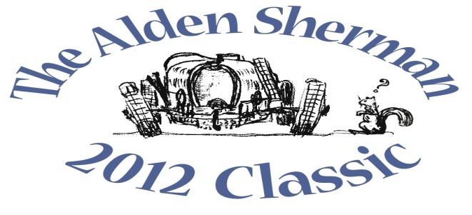
NEWS RELEASE

Vote for Your Favorite Cars and Motorcycles at Benefit Car Show

WESTON, CT, September 10, 2012 – You don’t have to be an automobile collector to get in on the action at The Alden Sherman Classic, a benefit car show that will be held on the grounds of Weston High School on September 23, 10 AM – 3 PM. Everyone attending the show will have the opportunity to vote for his or her favorite cars and motorcycles, with “People’s Choice” trophies awarded to cars representing different decades – from pre-war to present day – as well as to motorcycles, race cars, Best in Show and more.
“Collectible cars, motorcycles and race cars are coming from all over Fairfield County to be a part of our show,” said Wendy Petty, Director of the Weston Senior Activities Center, which is co-hosting the event with Friends of the Weston Senior Activities Center. “The owners will be with their vehicles to answer any questions, and there’s always a great story behind every car. It will be a lot of fun for kids of all ages.”
The Alden Sherman Classic is free and open to the public, with a suggested tax-deductible donation at the gate. Proceeds will support the Weston Senior Activities Center, which serves the active senior community in Weston and surrounding towns. There will also be a silent auction, featuring a number of unique items for bid. These include a once-in-a-lifetime private concert by music superstar Jose Feliciano and a full day of professionally-coached track time at historic Lime Rock Park. Former Emmy-Award winning NBC Nightly News anchor John Seigenthaler will be the master of ceremonies for the event.
For more information about the benefit car show and silent auction, please visit www.aldenshermanclassic.com or call Wendy Petty at (203) 222-2608.
# # #
Media Contact:
Karen DeMartine
DeMartine Group
203-221-2790
kdemartine@demartinegroup.com

Photo: (.jpeg file of photo below is attached)

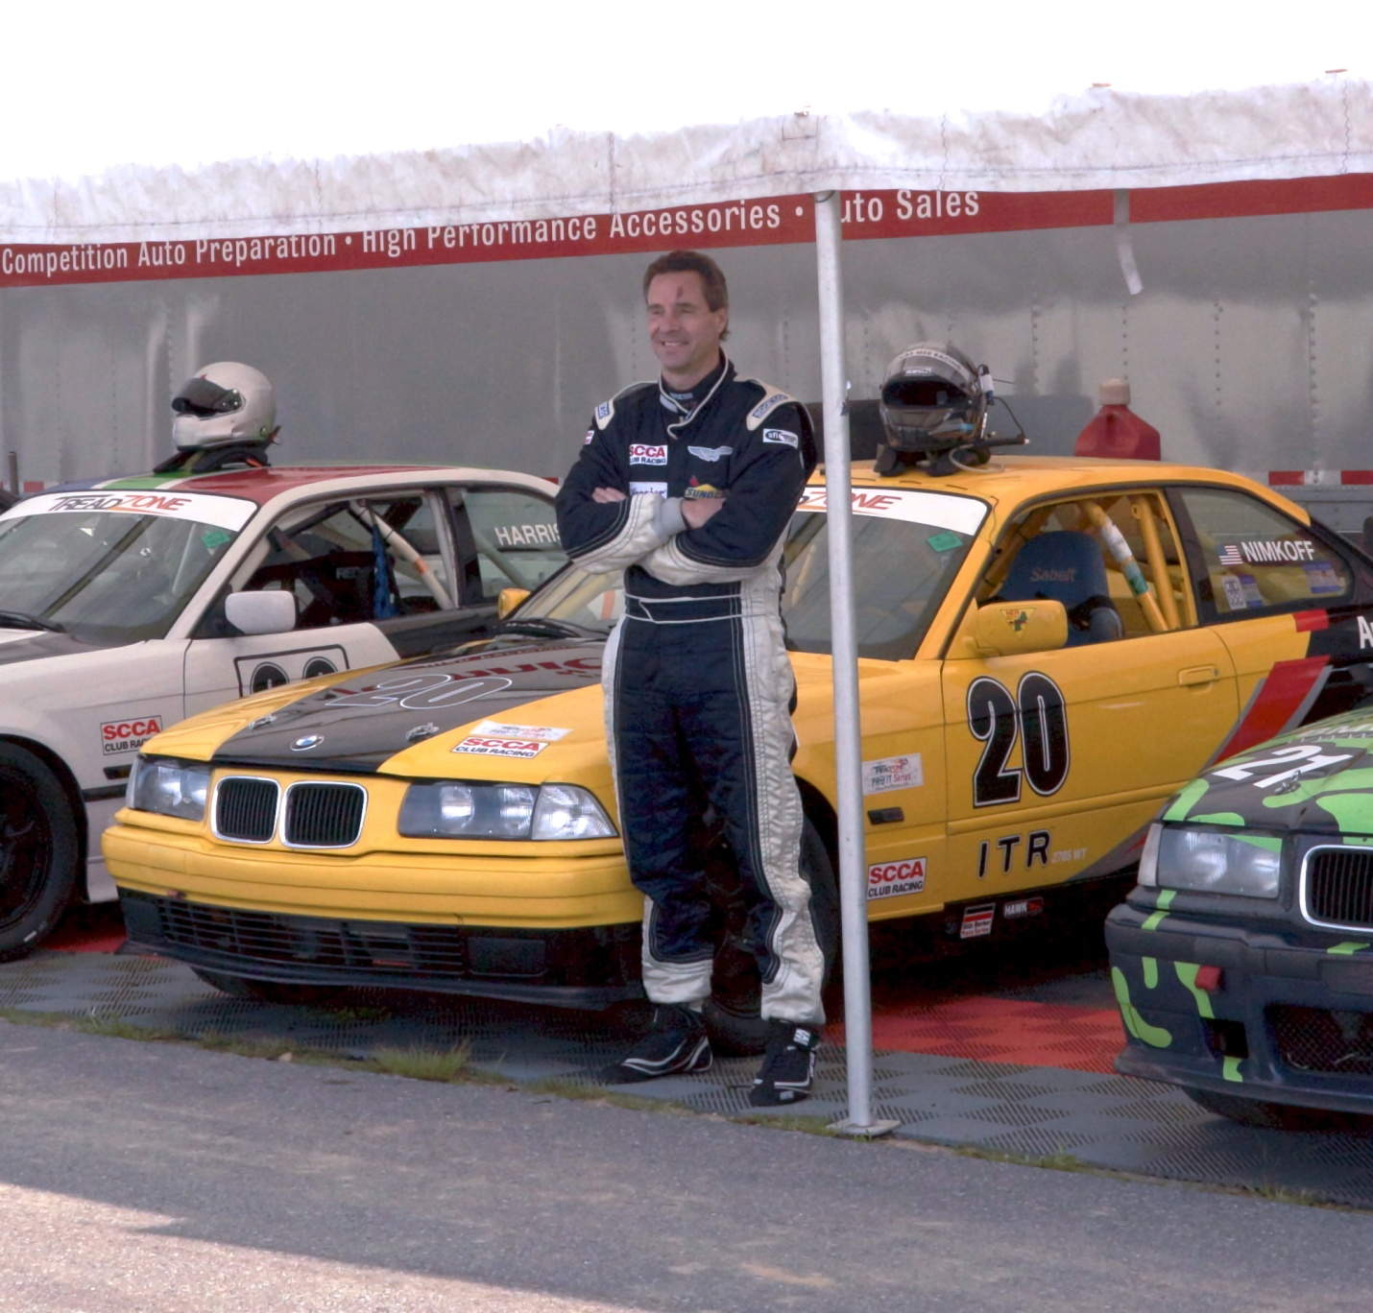
Caption: Weston resident Rob Nimkoff, who has pursued his passion for high performance driving since 2000, stands next to the BMW 325is that he races in the PRO IT Series. He also races an Aston Martin Vantage GT4 in the SCCA’s SafeRacer National Racing Series. Nimkoff is part of the organizing committee for The Alden Sherman Classic, a benefit car show that will showcase collectible cars, motorcycles and race cars on September 23, 10am – 3 pm, at Weston High School in Weston, CT.

