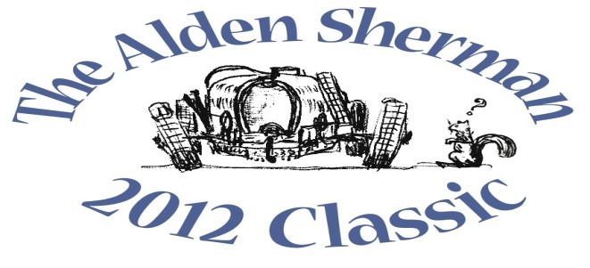

NEWS RELEASE

First Annual Alden Sherman Classic Benefit Car Show
Features Collectible Cars, Motorcycles, Race Cars from all over Fairfield County

WESTON, CT, September 10, 2012 – Named after longtime Weston resident and legendary car enthusiast Alden Sherman, the first annual Alden Sherman Classic benefit car show will be held on Sunday, September 23, 10 AM – 3 PM, at Weston High School on School Road in Weston, CT. Proceeds from the show will benefit the Weston Senior Activities Center, which serves and supports the active senior community in Weston and surrounding towns.
The event will showcase premier cars, motorcycles and race cars from the collections of car enthusiasts from all over Fairfield County and beyond. Anyone attending the show will have an opportunity to vote for his or her favorite vehicles in the exhibition. Based on these votes, “People’s Choice” awards will recognize cars in the different decades represented at the show, from pre-war to present day, as well as a special category for motorcycles and race cars.
“Nearly everyone has a car they feel passionate about, whether it’s a 1965 Mustang they always wanted to own or the first car they ever bought,” said Wendy Petty, Director of the Weston Senior Activities Center. “This show is about America’s longstanding fascination and love affair with the automobile, and it’s for a good cause, too.”
The event is free and open to the public, with a suggested tax-deductible donation at the gate. There will also be a silent auction to benefit the senior center, with a number of exciting items for bid, including a once-in-a-lifetime private concert by music superstar Jose Feliciano and a full day of professionally-coached track time at historic Lime Rock Park. Former Emmy-Award winning NBC Nightly News anchor John Seigenthaler will be the master of ceremonies for the event.
For more information about the benefit car show and silent auction, please visit www.aldenshermanclassic.com or call Wendy Petty at (203) 222-2608.
# # #

Media Contact:
Karen DeMartine
DeMartine Group
203-221-2790
kdemartine@demartinegroup.com

Photo: www.aldenshermanclassic.com/Photos.html

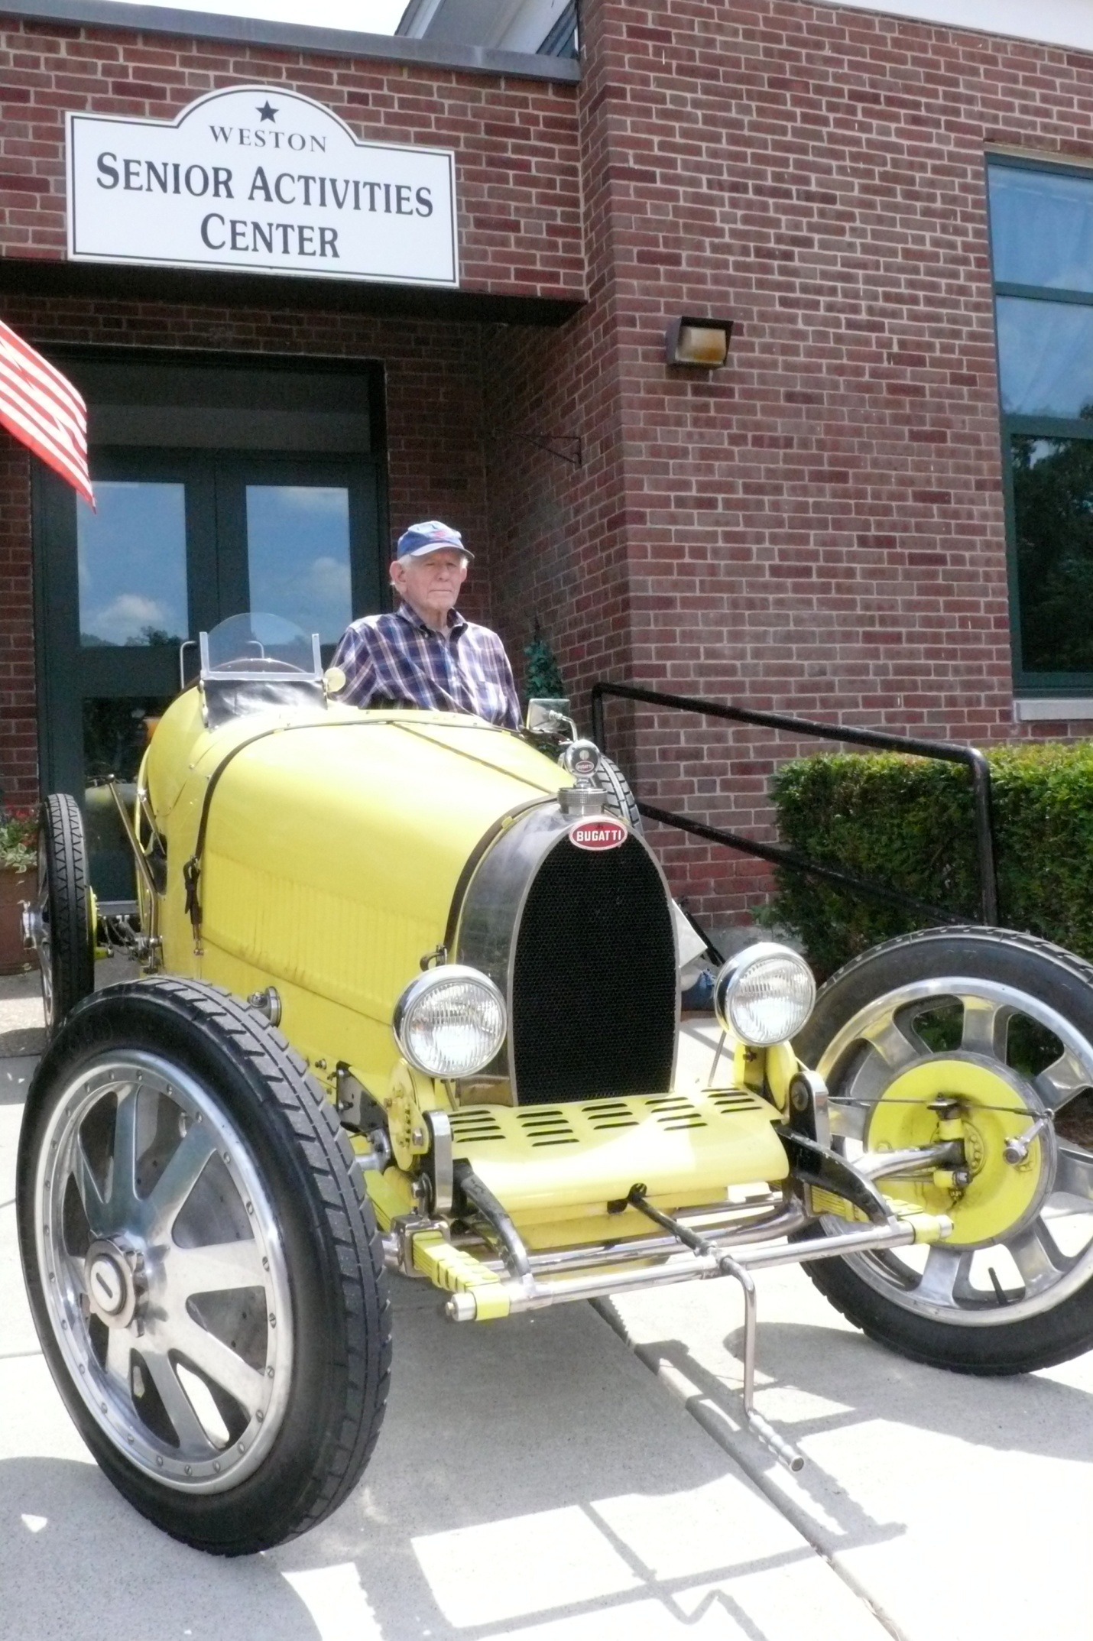

Caption: Well-known classic car enthusiast and Weston resident Alden Sherman poses in a 1926 Type 37 Grand Prix Bugatti in front of the Weston Senior Activities Center in Weston, CT. This model is one of 291 that were built between 1925 and 1929, and will be among the many beautifully restored automobiles, motorcycles and race cars to be featured at The Alden Sherman Classic on September 23, 10am – 3 pm, Weston High School grounds. Photo by Bob Mitchell.

