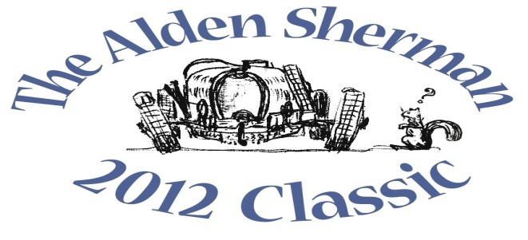
NEWS RELEASE

Collector Car Show Comes to Weston on Sunday

WESTON, CT, September 13, 2012 – In a rally of support for the seniors in Weston and neighboring towns, car enthusiasts from all over Fairfield County will come together on Sunday, September 23, 10am-3pm, for a benefit car show, The Alden Sherman Classic, at Weston High School. More than 100 collectible cars, motorcycles and race cars will be on display for the Weston Senior Activities Center’s first major fundraiser since its modest beginnings in the early 1970s. The show is named after Weston senior Alden Sherman, a local legend among car collectors, who will be at the event.
“Over the years, Weston residents have done an outstanding job enhancing our town as a place where families want to raise their kids,” said Wendy Petty, Director of the Weston Senior Activities Center. “Now we have an opportunity to do something really special for another vital segment of our community – our seniors.”
About 40 years ago, a handful of volunteers started preparing and serving lunch on Wednesdays to seniors, forming the basis of today’s Senior Center. These Wednesday lunches at Norfield Congregational Church Parish Hall are still a popular tradition. In 2006, the Senior Center expanded into its own space at Hurlbutt Elementary School. Today, the Senior Center continues to serve a thriving senior community who makes up almost 20 percent of Weston’s population.
“As the Senior Center increasingly becomes an important destination for our older neighbors, the need for fundraising is also growing,” Petty said. “Funds are needed to expand the Senior Center’s reach while helping cover the costs of exercise classes, health and wellness education, social outings, guest speakers and the other programs that we offer.”
The Alden Sherman Classic car show is open to all ages. Tax-deductible donations will be accepted at the gate. The suggested donation amounts are $20 for families, $10 for adults and $5 for seniors and kids. To add to the fun, everyone at the event will get a chance to vote in the “People’s Choice” awards for their favorite vehicles.
A silent auction will also be held at the show to benefit the Senior Center. A private concert by music superstar and Weston resident Jose Feliciano and a full day of professionally-coached track time at legendary Lime Rock Park are among the unique items up for bid. Former Emmy-Award winning NBC Nightly News anchor John Seigenthaler, also a Weston resident, will be the master of ceremonies for the event.
For more information about the benefit car show and silent auction, please visit www.aldenshermanclassic.com or call Wendy Petty at (203) 222-2608.
# # #
Media Contact:
Karen DeMartine
DeMartine Group
203-221-2790
kdemartine@demartinegroup.com

Photo: (.jpeg file of photo below is attached)
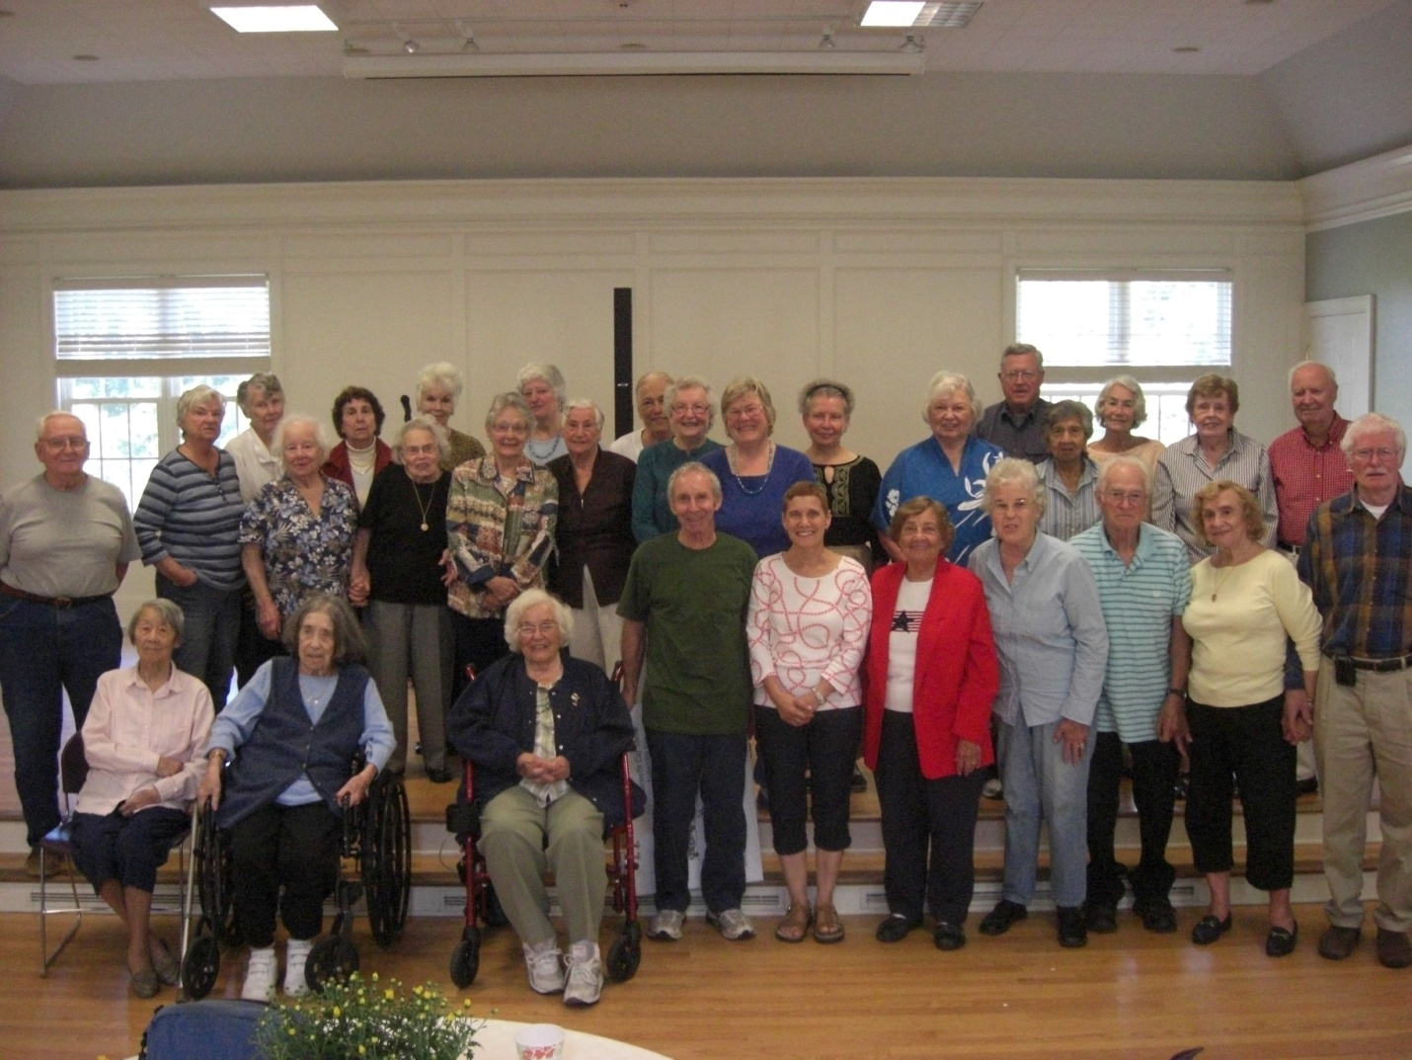
Caption: Every Wednesday for the past 40 years, seniors in Weston and neighboring towns have enjoyed a midday meal together at Norfield Congregational Church Parish Hall in Weston. A popular tradition, the Wednesday luncheons are prepared and served by volunteers. For more information about the Weston Senior Activities Center, please call Wendy Petty at (203) 222-2608.

