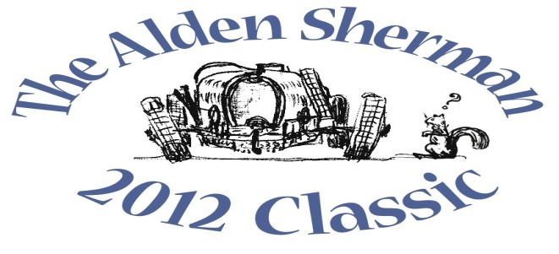
NEWS RELEASE

Milford Collector’s Award-winning Triumph Roadster to be
Featured at The Alden Sherman Classic Benefit Car Show

WESTON, CT, September 12, 2012 – Milford resident Gary Jones will stand proudly alongside his award-winning 1961 Triumph TR3 sports car at The Alden Sherman Classic on Sunday, September 23, 10am to 3pm, at Weston High School on School Road in Weston, CT. The Triumph roadster has been painstakingly restored to Concours condition, making it one of the finest of its class.
Jones will be joined by at least 100 other car and motorcycle enthusiasts from all over Fairfield County and beyond at The Alden Sherman Classic to show their collectible cars, race cars and motorcycles and answer questions about their vehicles. Anyone attending the show will have an opportunity to vote for his or her favorite cars and motorcycles. Based on these votes, “People’s Choice” awards will recognize cars in the different decades represented at the show, from pre-war to present day, as well as motorcycles, race cars, Best in Show and more.
“Nearly everyone has a car they feel passionate about, whether it’s a 1965 Mustang they always wanted to own or the first car they ever bought,” said Wendy Petty, Director of the Weston Senior Activities Center. “This show is about America’s longstanding fascination and love affair with the automobile, and it’s for a good cause, too.”
The Alden Sherman Classic is free and open to the public, with a suggested tax-deductible donation at the gate. Proceeds will support the Weston Senior Activities Center, which serves the active senior community in Weston and surrounding towns. There will also be a silent auction, featuring a number of unique items for bid. These include a once-in-a-lifetime private concert by music superstar Jose Feliciano and a full day of professionally-coached track time at historic Lime Rock Park. Former Emmy-Award winning NBC Nightly News anchor John Seigenthaler will be the master of ceremonies for the event.
For more information about the benefit car show and silent auction, please visit www.aldenshermanclassic.com or call Wendy Petty at (203) 222-2608.
# # #
Media Contact:
Karen DeMartine
DeMartine Group
203-221-2790
kdemartine@demartinegroup.com

Photo: (.jpeg file of photo below is attached)

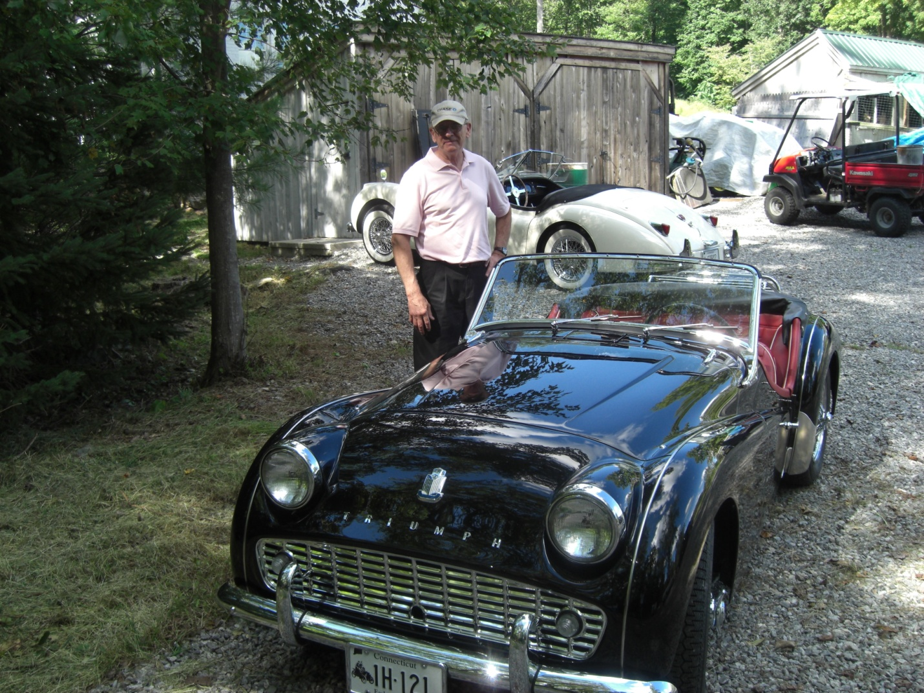

Caption: Milford resident Gary Jones stands next to his award-winning 1961 Triumph TR3. This Concours restoration, one of the finest of its class, will be among the many collectible automobiles, motorcycles and race cars featured at The Alden Sherman Classic on September 23, 10am – 3 pm, at Weston High School in Weston, CT.

