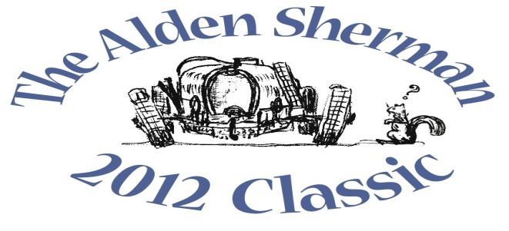
NEWS RELEASE

Redding Collector’s 1934 Packard 12 Phaeton to be
Featured at The Alden Sherman Classic Benefit Car Show

WESTON, CT, September 14, 2012 – Redding resident Bill King will stand proudly alongside his 1934 Packard 12 Phaeton at The Alden Sherman Classic car show on Sunday, September 23, 10am to 3pm, at Weston High School on School Road in Weston, CT. When the 1934 model was introduced, Packard was one of the indisputable leaders in prestige automobiles.
King, who is president of the Fairfield County Region of the Horseless Carriage Club of America (HCCA) and Antique Automobile Club of America (AACA), will be joined by more than 100 other car and motorcycle enthusiasts from all over Fairfield County and beyond at The Alden Sherman Classic. The show will present a fine selection of collectible cars, race cars and motorcycles, and everyone will have the opportunity to vote in the show’s “People’s Choice” awards for their favorite vehicles.
“Almost everyone has a car they feel passionate about, whether it’s a 1965 Mustang they always wanted to own or the first car they ever bought,” said Wendy Petty, Director of the Weston Senior Activities Center. “This show is about America’s longstanding love affair with the automobile, and it’s for a good cause, too.”
The Alden Sherman Classic car show is open to all ages. Tax-deductible donations will be accepted at the gate. The suggested donation amounts are $20 for families, $10 for adults and $5 for seniors and kids.
A silent auction will also be held at the show to benefit the Senior Center. A private concert by music superstar Jose Feliciano and a full day of professionally-coached track time at legendary Lime Rock Park are among the unique items up for bid. Former Emmy-Award winning NBC Nightly News anchor John Seigenthaler will be the master of ceremonies for the event.
For more information about the benefit car show and silent auction, please visit www.aldenshermanclassic.com or call Wendy Petty at (203) 222-2608.
# # #
Media Contact:
Karen DeMartine
DeMartine Group
203-221-2790
kdemartine@demartinegroup.com

Photo: (.jpeg file of photo below is attached)

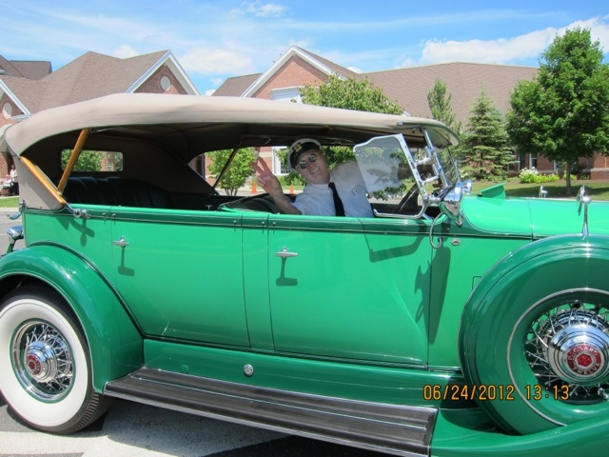

Caption: Redding resident Bill King is pictured above in his 1934 Packard 12 Phaeton, which was Packard’s elegant response to competitor Cadillac’s V-12 and V-16 engines introduced in the early 1930s. The stately antique will be among the many collectible automobiles, motorcycles and race cars featured at The Alden Sherman Classic on September 23, 10am – 3 pm, at Weston High School in Weston, CT.

