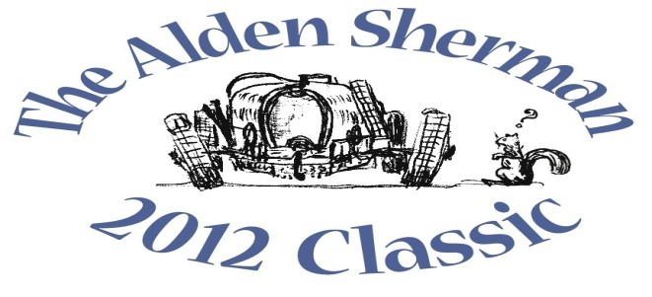
NEWS RELEASE DRAFT

Stratford Collector’s Porsche Spyder Tribute Race Car to be
Featured at The Alden Sherman Classic Benefit Car Show

WESTON, CT, September 6, 2012 – Stratford resident Al Baran will stand proudly alongside his re-creation of the legendary 1955 Porsche 550 Spyder race car at The Alden Sherman Classic on Sunday, September 23, 10am to 3pm, at Weston High School on School Road in Weston, CT. Fifty seven years ago in September 1955, the Porsche 550 Spyder was made famous when Hollywood icon James Dean died at its wheel in a car crash. An avid racer, Dean was on his way to a race in California.
Baran will be joined by many other car and motorcycle enthusiasts from all over Fairfield County and beyond at The Alden Sherman Classic to show their collectible cars, race cars and motorcycles. Anyone attending the show will have an opportunity to vote for his or her favorite cars and motorcycles. Based on these votes, “People’s Choice” awards will recognize cars in the different decades represented at the show, from pre-war to present day, as well as motorcycles, race cars, Best in Show and more.
“Nearly everyone has a car they feel passionate about, whether it’s a 1965 Mustang they always wanted to own or the first car they ever bought,” said Wendy Petty, Director of the Weston Senior Activities Center. “This show is about America’s longstanding fascination and love affair with the automobile, and it’s for a good cause, too.”
The event is free and open to the public, with a suggested tax-deductible donation at the gate that will be used to support the Weston Senior Activities Center, which serves the active senior community in Weston and surrounding towns. There will also be a silent auction to benefit the senior center, with a number of exciting items for bid, including a once-in-a-lifetime private concert by music superstar Jose Feliciano and his friend and colleague Bill Rother. Former Emmy Award winning anchor of NBC Nightly News John Seigenthaler will be the master of ceremonies for the event.
For more information about the benefit car show and silent auction, please visit www.aldenshermanclassic.com or call Wendy Petty at (203) 222-2608.
# # #

Media Contact:
Karen DeMartine
DeMartine Group
203-221-2790
kdemartine@demartinegroup.com

Photo: (.jpeg file of photo below is attached)

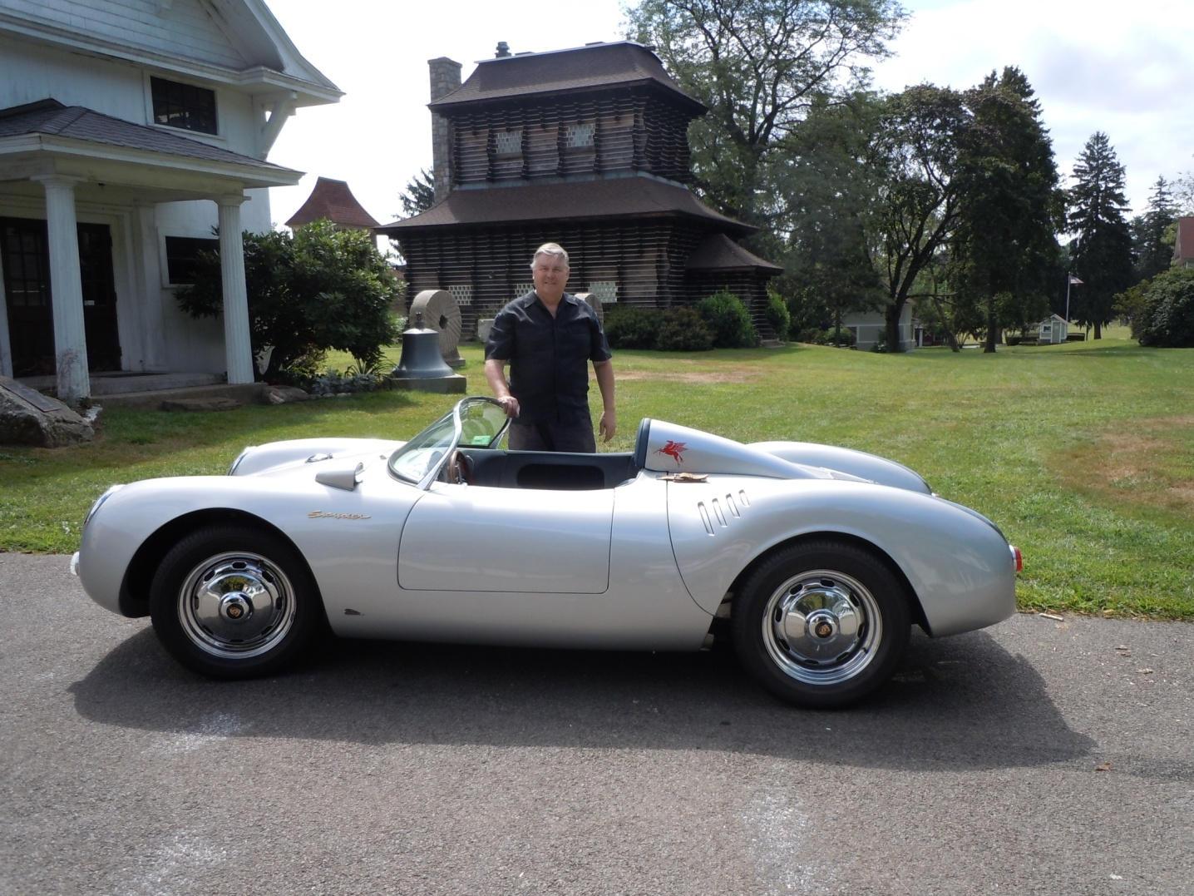

Caption: Stratford resident Al Baran stands next to his re-creation of the legendary 1955 Porsche 550 Spyder made famous 57 years ago by film star James Dean. Like the rare originals, this light weight, 1,300-pound car is powered by an air-cooled, 4-cylinder motor with an estimated 150 horsepower. The originals were formed in aluminum, while this version was replicated in fiberglass. Baran’s tribute car will be among the many collectible automobiles and motorcycles to be featured at The Alden Sherman Classic on September 23, 10am – 3 pm, at Weston High School in Weston, CT.

