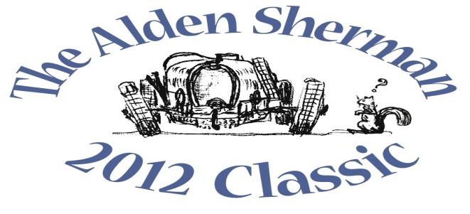
NEWS RELEASE

Trumbull Collector’s Pre-War MG to be
Featured at The Alden Sherman Classic Benefit Car Show

WESTON, CT, September 13, 2012 – Trumbull resident Phil Laiacona will stand proudly alongside his award-winning 1935 MG PA sports car at The Alden Sherman Classic car show on Sunday, September 23, 10am to 3pm, at Weston High School on School Road in Weston, CT. British sports car manufacturer MG Car Company produced the MG PA model in 1934 and 1935, limiting production to just 2,000.
Laiacona will be joined by more than 100 other car and motorcycle enthusiasts from all over Fairfield County and beyond at The Alden Sherman Classic. The show will present a fine selection of collectible cars, motorcycles and race cars, and everyone will have the opportunity to vote in the show’s “People’s Choice” awards for their favorite vehicles.
“Almost everybody has a car they feel passionate about, whether it’s a 1965 Mustang they always wanted to own or the first car they ever bought,” said Wendy Petty, Director of the Weston Senior Activities Center. “This show is about America’s longstanding love affair with the automobile, and it’s for a good cause, too.”
The Alden Sherman Classic car show is open to all ages. Tax-deductible donations will be accepted at the gate. The suggested donation amounts are $20 for families, $10 for adults and $5 for seniors and kids.
A silent auction will also be held at the show to benefit the Senior Center. A private concert by music superstar Jose Feliciano and a full day of professionally-coached track time at historic Lime Rock Park are among the unique items up for bid. Former Emmy-Award winning NBC Nightly News anchor John Seigenthaler will be the master of ceremonies for the event.
For more information about the benefit car show and silent auction, please visit www.aldenshermanclassic.com or call Wendy Petty at (203) 222-2608.
# # #
Media Contact:
Karen DeMartine
DeMartine Group
203-221-2790
kdemartine@demartinegroup.com

Photo: (.jpeg file of photo below is attached)

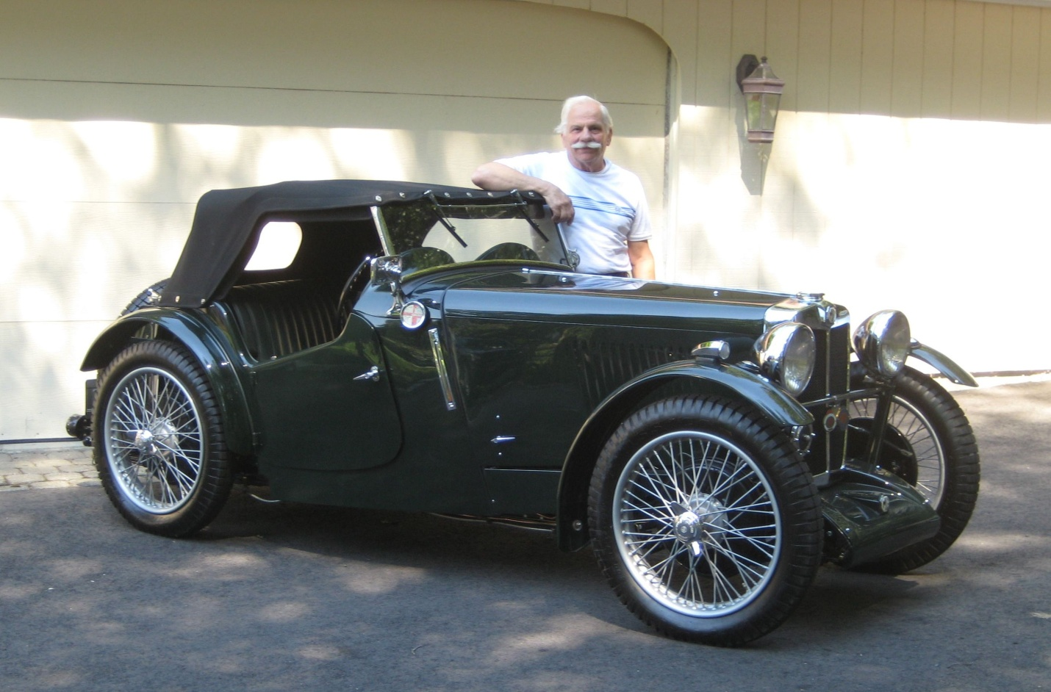

Caption: Trumbull resident Phil Laiacona is pictured above next to his award-winning 1935 MG PA. The pre-war sports car will be among the many collectible automobiles, motorcycles and race cars featured at The Alden Sherman Classic car show on September 23, 10am – 3 pm, at Weston High School in Weston, CT.

