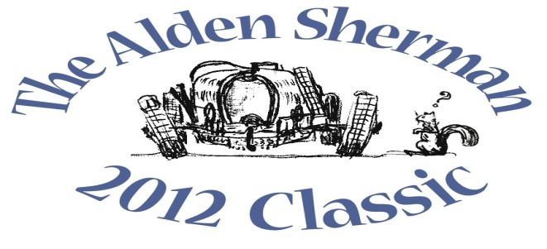
NEWS RELEASE DRAFT

Wilton Collector’s Austin-Healey 3000 to be
Featured at The Alden Sherman Classic Benefit Car Show

WESTON, CT, September 15, 2012 – Wilton resident Chauncey Johnstone will stand proudly alongside his 1960 Austin-Healey 3000 sports car at The Alden Sherman Classic car show on Sunday, September 23, 10am to 3pm, at Weston High School on School Road in Weston, CT. The best known of the so-called Big Healy models, the 3000 has a long and proud competition history, and has raced at most of the major racing circuits around the world.
Johnstone will be joined by more than 100 other car and motorcycle enthusiasts from all over Fairfield County and beyond at The Alden Sherman Classic. The show will present a fine selection of collectible cars, race cars and motorcycles, and everyone will have the opportunity to vote in the show’s “People’s Choice” awards for their favorite vehicles.
“Almost everyone has a car they feel passionate about, whether it’s a 1965 Mustang they always wanted to own or the first car they ever bought,” said Wendy Petty, Director of the Weston Senior Activities Center. “This show is about America’s longstanding love affair with the automobile, and it’s for a good cause, too.”
The Alden Sherman Classic car show is open to all ages. Tax-deductible donations will be accepted at the gate. The suggested donation amounts are $20 for families, $10 for adults and $5 for seniors and kids.
A silent auction will also be held at the show to benefit the Senior Center. A private concert by music superstar Jose Feliciano and a full day of professionally-coached track time at legendary Lime Rock Park are among the unique items up for bid. Former Emmy-Award winning NBC Nightly News anchor John Seigenthaler will be the master of ceremonies for the event.
For more information about the benefit car show and silent auction, please visit www.aldenshermanclassic.com or call Wendy Petty at (203) 222-2608.
# # #

Media Contact:
Karen DeMartine
DeMartine Group
203-221-2790
kdemartine@demartinegroup.com

Photo: (.jpeg file of photo below is attached)

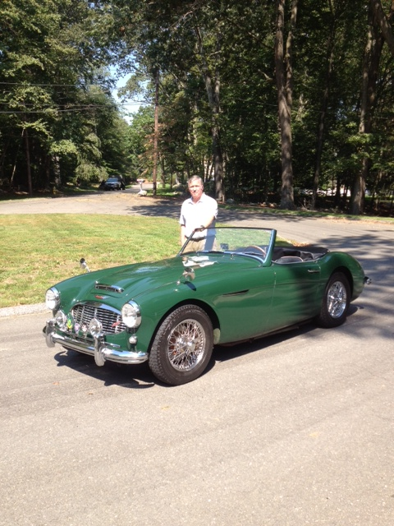

Caption: Wilton resident Chauncey Johnstone is pictured above next to his 1960 Austin-Healey 3000. The “Big Healy” 3000 model was first introduced in 1959 and has since won numerous European rallies in its class. The British sports car will be among the many collectible automobiles, motorcycles and race cars featured at The Alden Sherman Classic on September 23, 10am – 3 pm, at Weston High School in Weston, CT.

